METHODOLOGY
In this chapter, the different procedures in creating and analyzing the system are discussed. The Project Design focuses on 2 subtopics: the System Framework, which enables the reader to visualize the connection between the main components of the Cubies 2D Mobile Game, and the Process Flow, which illustrates the complete Data Flow Diagram of the said game. The Project Development tackles the Waterfall Model with Prototyping and the justification of the researchers as to why they chose such system. And lastly, the Testing and Evaluation Procedure discusses the procedures in conducting the system that the respondents (Technical experts and End-users) must be familiar with. It also involves the discussion of the statistical treatment of data to be done by the researchers.

Project Design

System Framework
Figure 10 shows the system framework of our system. The user can only access the system through a “medium” which is a mobile phone. Next, the program runs the graphic design coordinates with it which will enable the user to see the environment of the game.

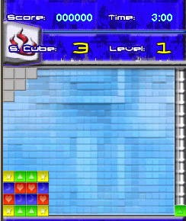
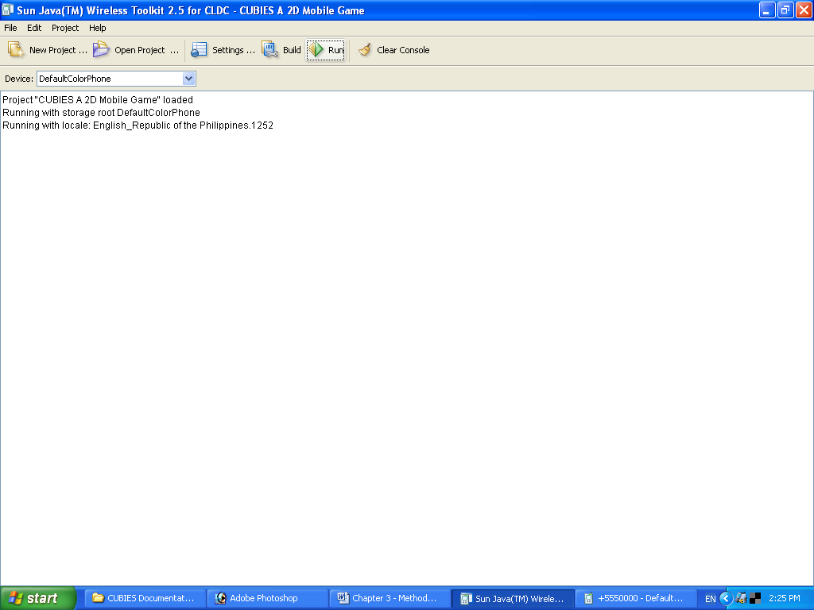


User

Program



Graphic Design

Mobile Phone

Figure 10: System Framework for the Cubies 2D Mobile Game

Process Flow
Figures 11 and 12 illustrate the Context Diagram and Diagram 0 of the Cubies 2D Mobile Game respectively, which serves as a guide for users in playing our game. While Figures 13 and 14 shows the Child Diagram of Processes 4 and 8 respectively. As the user opens the game, introduction will be the first to be shown and followed by menu. The user will choose one of the menu options namely: New Game, Continue Game, High Score, Settings, Instructions, and Exit. In the New Game option, the user will play from the first level up to the last level. The Continue Game option, the user will continue the previous game level where he had left. The High Score option displays the name of the 5 top scorers of the game including the highest level that they reach and their corresponding scores. The Settings option allows the user to configure settings for the game. The Instruction option, it shows the step-by-step instructions about the mechanics of the game. Lastly, the Exit option allows the user to close the application.

USER
USER

0

CUBIES:

2D Mobile

Game

Game result
User selection
(New Game, High Score, Settings, Instructions and Exit)

Score
High score

Game Instruction
Configured game setting (Difficulty level, Sound settings, and Control settings)

Figure 11: Context Diagram for the Cubies 2D Mobile Game

High score
USER

High score
High Score option
7

Display
high
Score
User selection
(New Game,
Continue Game, High score, Settings, and Instructions)

6

Instruct
user about
the game

1

Accept
user
selection
Game instruction
Instruction option
USER

Settings option

8

Configure
Settings

2

Generate game
environment
3

Play
game
4

Determine
high score

D1 High score
USER
Configured game settings (Difficulty level, Sound settings, and Control settings)
Score
Game result
Score
Game environment
New Game option

Highest
score
Current
high
score

Figure 12: Diagram 0 for the Cubies 2D Mobile Game

D1 High score

Current high score
Highest score

Score

4.1
Compare score from current
high score

4.2
Save
highest
score

Highest score

Figure 13: Child Diagram of Process 4 in Diagram 0

8.1

Select game settings

User selection (Difficulty settings, Sound settings, and Control settings)
Settings option
8.2

Accept user
selection

8.4

Adjust game sound

USER
8.3

Choose a difficulty level (easy, normal, or hard)
8.5

Choose a set of controls
Configured Control settings
Configured difficulty level
Configured Sound settings
Control settings
Difficulty level settings
Sound settings
Figure 14: Child Diagram of Process 8 in Diagram 0
Project Development

Waterfall model has been used to prescribe software development activities. It will be very useful for us developers to lay out what we need to do. Its simplicity makes it easy for us to explain to those unfamiliar with software development. Many other, more complex models are really just embellishments of the waterfall model, incorporating feedback loops and extra activities.
However the waterfall model tells us nothing about the typical back and forth activities that will lead to the final product. Software development involves changes even during other phases are occurring and to solve this problem the researchers integrated the waterfall model with prototyping so that changes can be made in the process (as shown in Figure 15).

Analysis of Gathered Information
System Implementation
Program Design
Requirements Analysis, Definition and Information Gathering

System Design
System Testing
Documentation
Prototyping
Validate
Check

Figure 15: Waterfall Model with Prototyping

Requirements Analysis, Definition and Information Gathering
The first phase is very essential in the development of our system, this is where we will discern and define the requirements for the system to be built, and as soon as the requirements are defined, gathering of information takes place. We should consider three methods of gathering information and that is through library research, Internet research and through interview.
Analysis of Gathered Information
Analysis of the gathered information is very crucial to the development of our system as it goes hand in hand with the first phase. Because whatever will be the result in the analysis of gathered information, we will use this as basis for the succeeding phases in the software development process.
System Design
After the first two phases comes the System Design. This is where we will transform the requirements into a layout of what the system will look like in the user’s perspective, what it will do and how it will interact with the user. It must contain a complete description of the functions and interactions involved.
Program Design
Once the system design is done it will be used to generate the design for the program of our system. Notice that programs come only after the functionality and appearance have been defined. This is because when the system design is accepted, the developers can now discuss programs with its basis, a well-defined description of the system.
System Testing
Once the programs have been written, they are tested and evaluated if all the requirements have been met, it will be checked if the system serves its intended purpose. To do so, it will go back to the first phase to validate if the system conforms to the defined requirements. If there are no problems with the system, then it will proceed to documentation.
Documentation
Once all the phases have been done, with no problems and inconsistency, documentation of the system takes place.
Implementation
In the last phase of software development, the implementation of our system will be put into operation. It also includes the maintenance of the system.

Testing and Evaluation Procedure

- The type and number of respondents
The expected number of respondents that must test and evaluate our system is 40, where 20 respondents are technical experts and the other 20 being the end-users. Both types of respondents will not be difficult to find since most people are familiar with using a mobile phone.
- Evaluation Instrument
The respondents will rate our system with the use of an evaluation instrument, which is provided by the researchers. There are 5 criteria in rating our system. First, the Installability involves the ease of setting up the system in various cellphone models. Second, the Functionality focuses on the ease of loading and user-friendliness in using our system. Third, the Reliability searches the absence of failures and recoverability in using our system. Fourth, the Availability looks for the completeness, and the conformance of our system to the established requirements. And lastly, the Maintainability looks for the testability.
Each of these software criteria can be graded by knowing the rating scale is listed in the table with their corresponding range and its equivalent:
4.51 – 5.00 | Excellent
3.51 – 4.50 | Very Satisfactory
2.51 – 3.50 | Satisfactory
1.51 – 2.50 | Fair
1.00 – 1.50 | Poor

Table 1: Rating Scale in the Evaluation Instrument
- Steps in conducting the testing
  - The researchers will distribute the evaluation instrument to 40 respondents (20 being the technical experts and the other 20 being the end-users).
  - The respondents must be oriented with the 5 criteria for testing and evaluating the software.
  - They will test the Cubies 2D Mobile Game with the use of a mobile phone or with the use of an emulator provided by J2ME in their Personal or Laptop Computers.
  - After the respondents completely test the game, they will rate our software by answering the evaluation instrument and placing a checkmark under each corresponding numerical rating with 5 being excellent and 1 being poor. They must answer the content of our evaluation instrument completely and as honestly as possible. They must compute for the Total Score by adding each score from the 5 software criteria. They may include comments and suggestions for further improvement of the system.
  - The researchers will collect all the evaluation instruments from the respondents. After which, the researchers will double check the computations done by the respondents in the evaluation instrument.
  - From their evaluation instruments, we will be able to interpret and analyze the respondent’s feedback with the use of statistics. From this point, the statistical treatment of data comes in.
- Statistical Treatment of Data
In order for the researchers to compute for the overall rating of our system, the necessary statistical formulas such as Mean and Standard Deviation are to be used.
Below are the steps that are to be done by the researchers to know the acceptability of our system in both quantitative and qualitative terms:
- After collecting all the evaluation instruments from the respondents, we can get the Mean by using the formula:
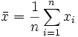
It is computed by adding all X_{i}’s from 1 to n, which comprises all the total scores from all the evaluation instruments and then divide it by n, which is the total number of respondents who answered the evaluation instrument.
- To enable the researchers to judge the reliability of the mean, Standard Deviation must be determined. It measures the degree of how the values in the distribution are scattered. It is computed by using the formula:
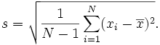
In the formula, the mean is the value determined in Step 1. From here, subtract each Xi to the mean and then square each difference. And lastly, add all the squared values and divide the sum to n minus 1.
- For us to interpret the statistical results of our findings, the researchers must create a Frequency Distribution based from all the evaluation instruments answered by respondents. It is made by determining the range, which is the difference between the highest total score and the lowest total score from the evaluation instrument. To get the class size, divide the range with the desired number of class intervals. After getting the class size, we can also get the class mark by adding the 2 class intervals and divide by 2. Tally the frequencies for each interval based from the scores of each evaluation instrument.
- Finally, for the readers to interpret the statistical results of our findings, we will represent the Frequency Distribution graphically by constructing a Frequency Polygon wherein the values in the x-axis represents the scores from the evaluation instrument and the values in the y-axis represents the number of respondents who answered the evaluation instrument.

